May the force be with you...
FORCES ACTING BETWEEN MOLECULES

(Intermolecular forces)

- Molecule is a group of atoms joined together by covalent bonds.

- Intermolecular forces are weak attractions that exist between molecules.

- The intermolecular forces determine the attractions between molecules and, hence, the amount of energy which needs to be used to separate them, i.e. to boil the substance.

- When a molecular substance is turned to a gas only intermolecular forces are broken not bonds.

- There are three varieties of intermolecular force.

1. Dispersion (Van der Waals’) forces

- Non-polar molecules have small, temporary, fluctuating dipoles due to random movement of electrons;
- A temporary dipole induces the dipole on other molecule.
- The larger the molecule - greater number of electrons - the larger temporary dipoles and so greater attractive forces between molecules, which are van der Waals’ forces.

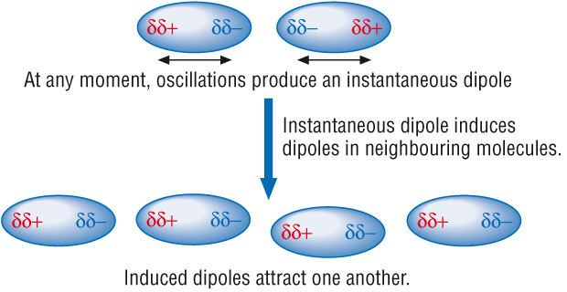

Even the noble gases, which exist as single atoms, have weak intermolecular forces due to van der Waals’ forces.

Noble gas | Boiling point/ºC | Number of electrons
He | -269
Ne | -246
Ar | -186
Kr | -153
Xe | -108
Rn | -62

As the number of electrons increases, so does the strength of the dispersion forces.
The boiling point increases as we move down the noble gas group.
? 1. Describe how dispersion forces arise.

2. The boiling points of the group 7 elements are shown below.

Element | F₂ | Cl₂ | Br₂ | I₂
Boiling point/ °C | -188 | -34.7 | 58.8 | 184

Explain this trend, in terms of intermolecular forces.

2. Permanent dipole-dipole interaction

- Polar molecules have permanent dipoles.
- The permanent dipole of one molecule attracts the permanent dipole in a different polar molecule to form permanent dipole-dipole force between those molecules.

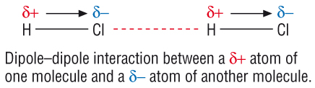

Molecules with permanent dipoles have stronger forces between molecules than molecules with induced dipoles.

HCl and F₂ contain an equal number of electrons and should therefore have similar dispersion forces. The huge difference in their boiling points is due to HCl having a permanent dipole.

Substance | HCl | F₂
Boiling point/ ° C | -85 | -188

3. Hydrogen bonding

Hydrogen bonds are the strongest type of intermolecular force.
Definition: A hydrogen bond is a strong dipole-dipole attraction between an electron deficient hydrogen atom attached to an electronegative atom (N, O or F), and the lone pair of electrons on a highly electronegative atom on a different molecule.

Hydrogen bonding between water molecules

Exercise 11
Draw diagrams to show hydrogen bonding between water molecule and:

- an ethanol molecule

- an ammonia molecule

Exercise 12
a) Draw a diagram to show hydrogen bonding between hydrogen fluoride molecules

Explain the trend in boiling points in the series: HCl, HBr, HI. Why is the boiling point of hydrogen fluoride, HF, out of the line in the series?
Compound | HF | HCl | HBr | HI
Boiling point/ ° C | 20 | -85 | -67 | -35

Exercise 13

1. Urea is soluble in water due to the formation of hydrogen bonds between its molecule and water molecules. Urea is a solid at room temperature because of hydrogen bonding between the urea molecules.

(a) Complete diagram for urea molecule by showing all the lone pairs and permanent dipoles.

[3]

(b) Show a hydrogen bond between a water molecule and your urea molecule.

[3]

Background reading

Rosalind Elsie Franklin (1920 – 1958) was an English biophysicist and X-ray crystallographer who made important contributions to the understanding of the fine structures of DNA, viruses, coal and graphite. Franklin is best known for her work on the X-ray diffraction images of DNA which were an important influence on Crick and Watson’s 1953 hypothesis regarding the structure of DNA. When her work was published it represented evidence in support of their hypothesis. Later she led pioneering work on the tobacco mosaic and polio viruses.
She died at the age of 37 of complications arising from cancer of the ovary.



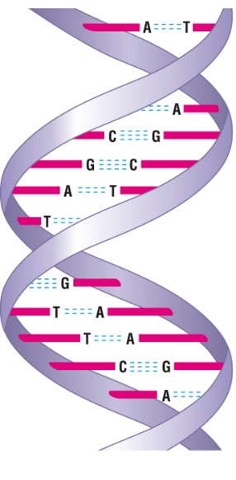
Hydrogen bonding in DNA
Hydrogen bonding occurs in organic molecules containing N-H groups - in the same sort of way that it occurs in ammonia. Examples range from simple molecules like CH₃NH₂ (methylamine) to large molecules like proteins and DNA.
The two strands of the famous double helix in DNA are held together by hydrogen bonds between hydrogen atoms attached to nitrogen on one strand, and lone pairs on nitrogen or an oxygen on the other one.

Exercise 14

Complete a diagram by showing relevant dipoles, lone pair of electrons and hydrogen bonding between molecules of Adenine and Thymine.

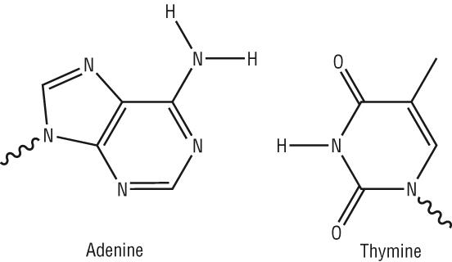

Physical properties of covalent compounds

Most covalent compounds:

- have low melting points

- dissolve in non-polar solvents

- do not conduct electricity

Exercise 15
Answer the following questions:
- Why do most covalent compounds have low melting points?

- Name a covalent compound with a high melting point?

- Covalent compounds often dissolve better in non-polar solvents than in water.
Give an example of a non-polar solvent.

- Name a covalent compound that dissolves in water.

- Name a covalently bonded substance which can conduct electricity.

The peculiar nature of water:

Work in small groups to complete the following exercise

Exercise 16

Property 1:

Explanation:

Property 2:

Explanation

Other properties:

The structure and density of ice
Use the following words to help you to complete the exercise about the structure and density of ice:

apart, free, permanently, less

When water freezes, the water molecules are not _______ to

move about and hydrogen bonds form _____________.

Ice has an open structure in which H₂O molecules are further

_____________ than H₂O molecules in water. This leads to the

unusual situation in which ice is ____________ dense than

water.
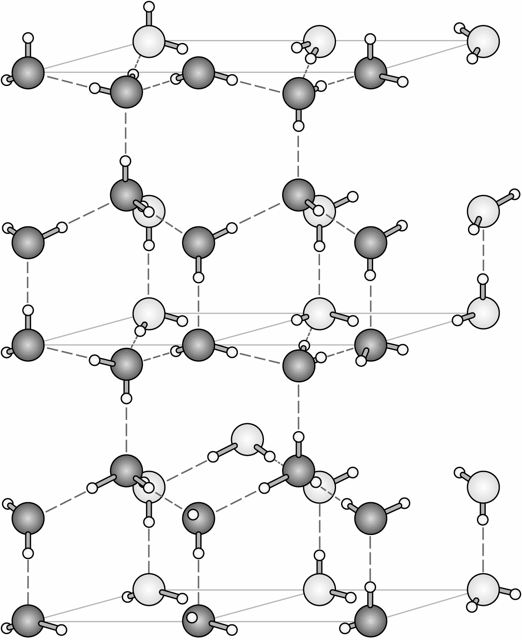

The boiling point of water

Hydrogen bonding accounts for the boiling point of water being much higher than expected for such a small molecule.
Hydrogen bonds are extra-strong permanent dipole attractions that are much stronger than other intermolecular forces. More heat energy needed to be supplied to overcome the strong intermolecular forces of attraction – hydrogen bonds.

